Task on S3
1.Create an S3 bucket and upload some objects to S3.
Step 1: Open S3
- Sign in to the AWS Management Console.
- Search for S3 and open it.
Step 2: Create a Bucket
- Click Create bucket.
- Enter a unique bucket name : devtechie
- Select an AWS Region.
- Leave the default settings (or keep Block Public Access enabled).
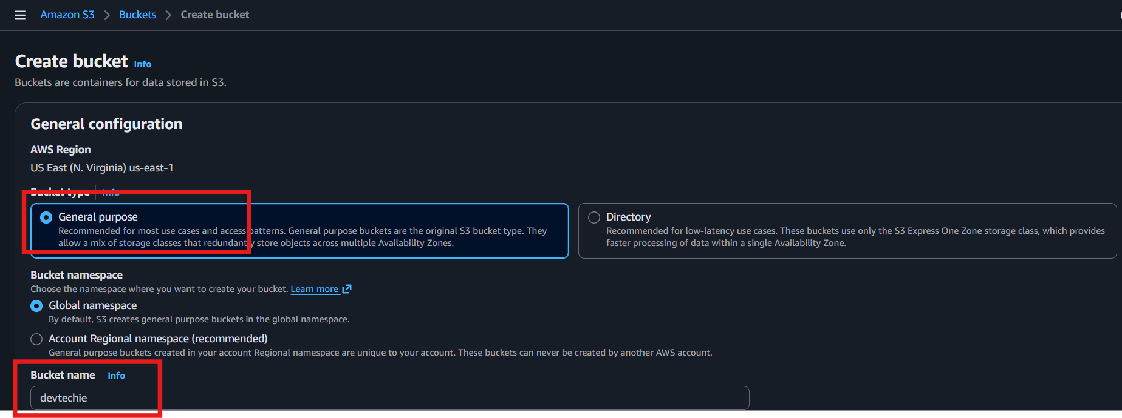
- Click Create bucket.
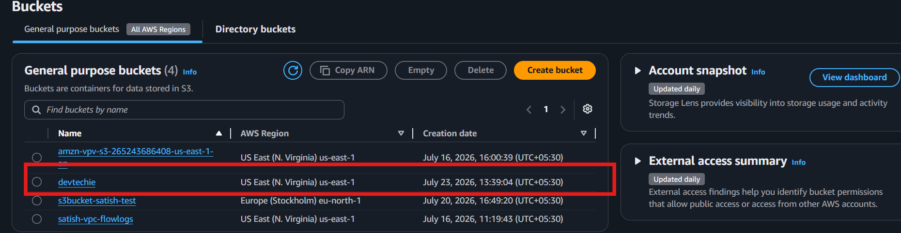
Step 3: Open the Bucket
- Click the newly created bucket name.
Step 4: Upload Objects

- Click Upload.
- Click Add files (or Add folder).
- Select the file(s) from your computer.
- Click Upload.
Step 5: Verify
- Ensure the uploaded files appear in the bucket's Objects tab.
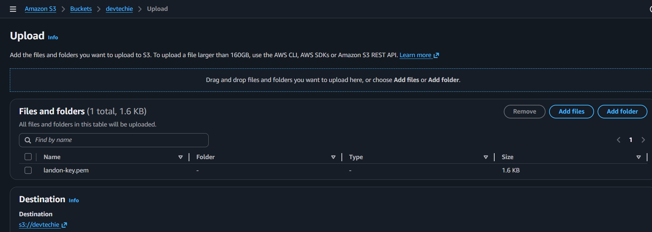
Outcome:
- ✅ S3 bucket created successfully.
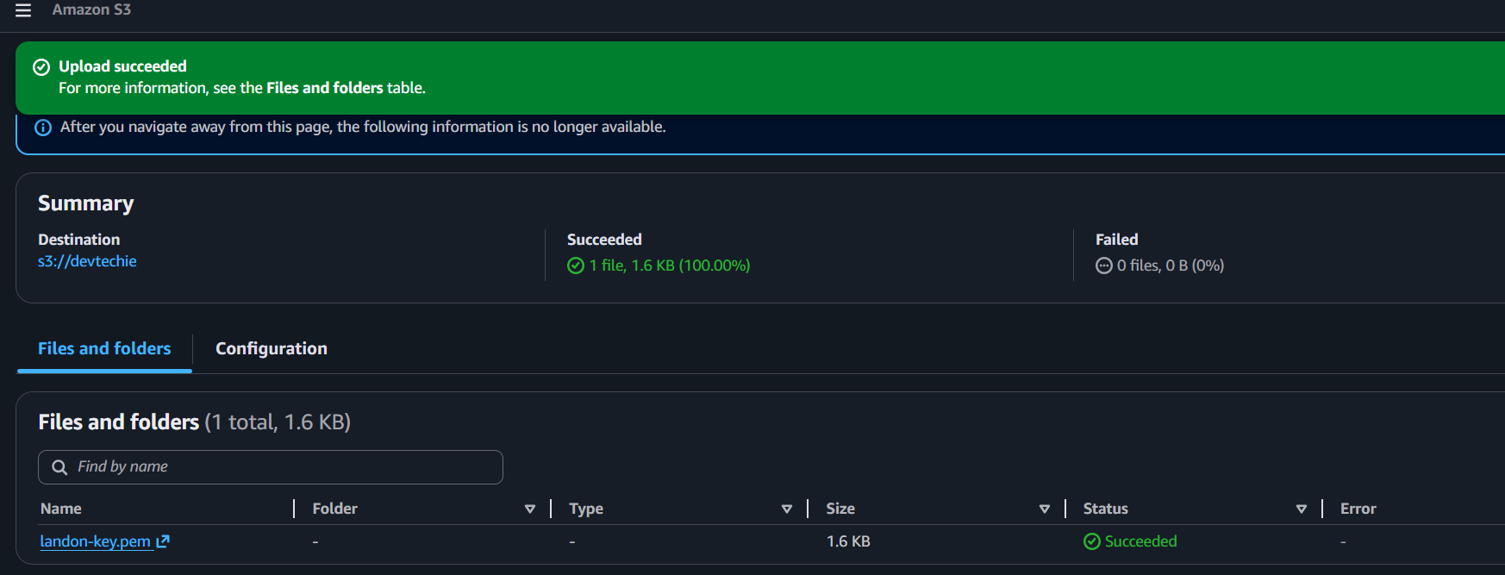
- ✅ Files uploaded and visible in the bucket.

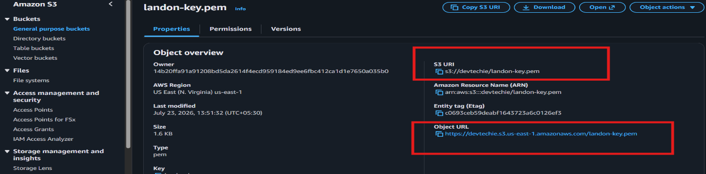
Object URL and bucket URL

When we click on object URL it will open file
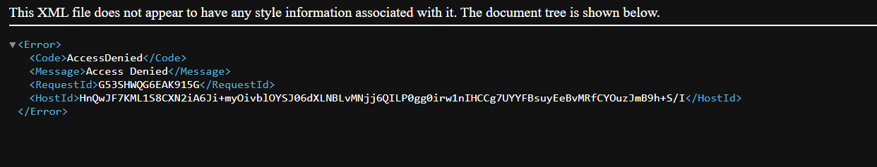
Here we don’t have permission to open file so we need to give permission.
It blocks the public access initially
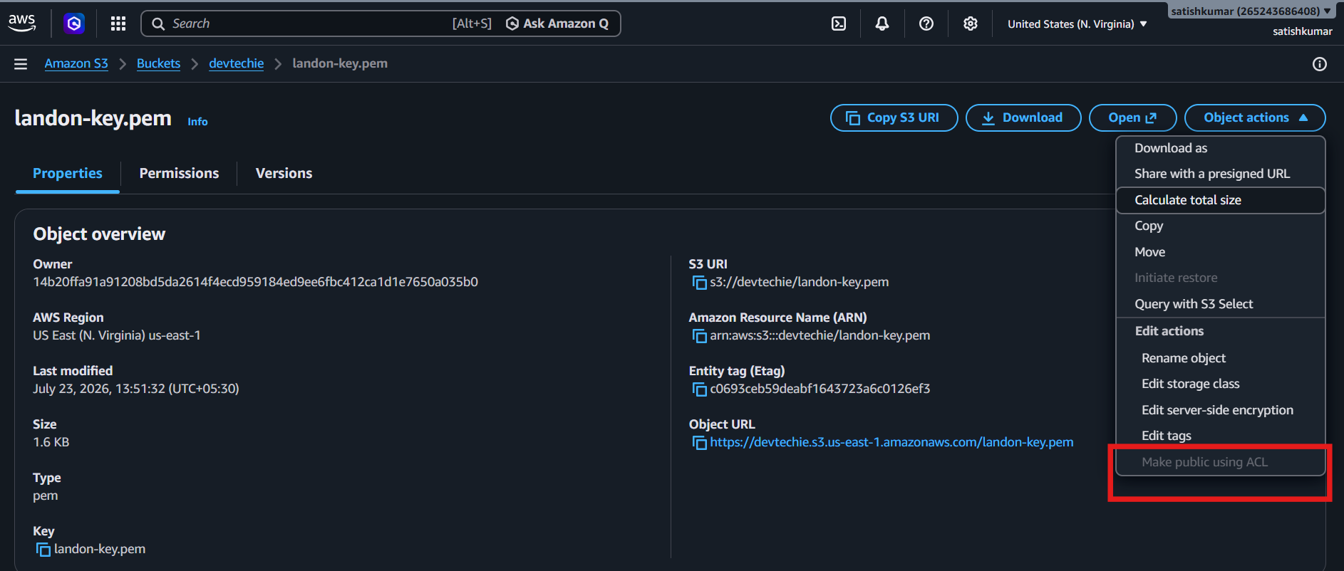
ACL need to enable if we want to give permissions
Go to s3 bucket and click on permission
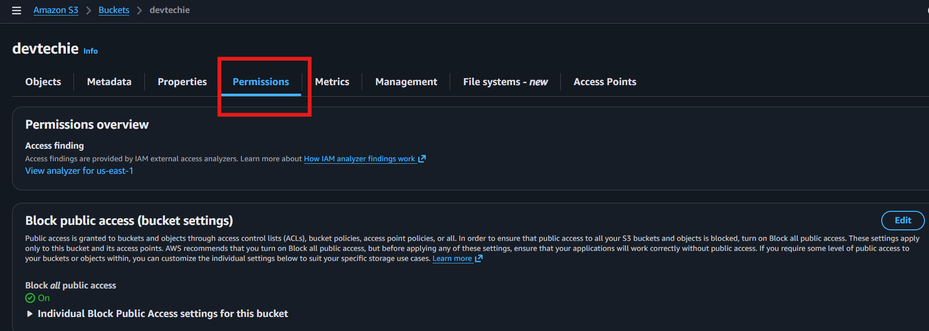
So to ACL- edit
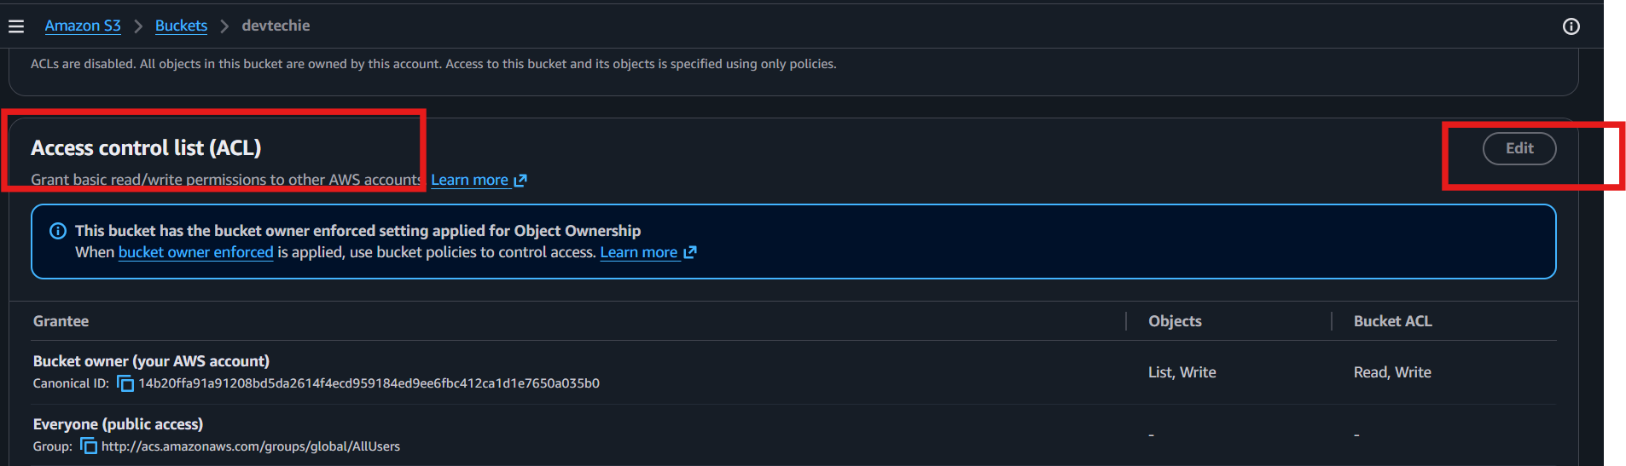
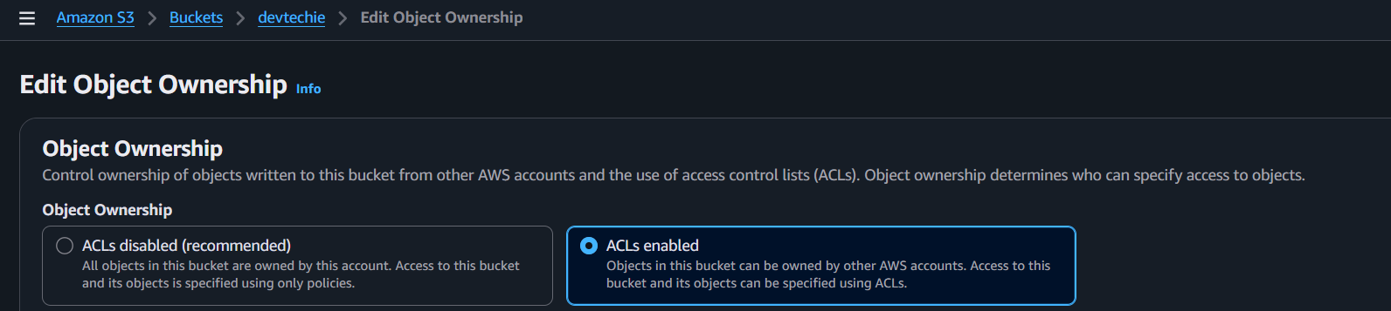
Untick block all public acces
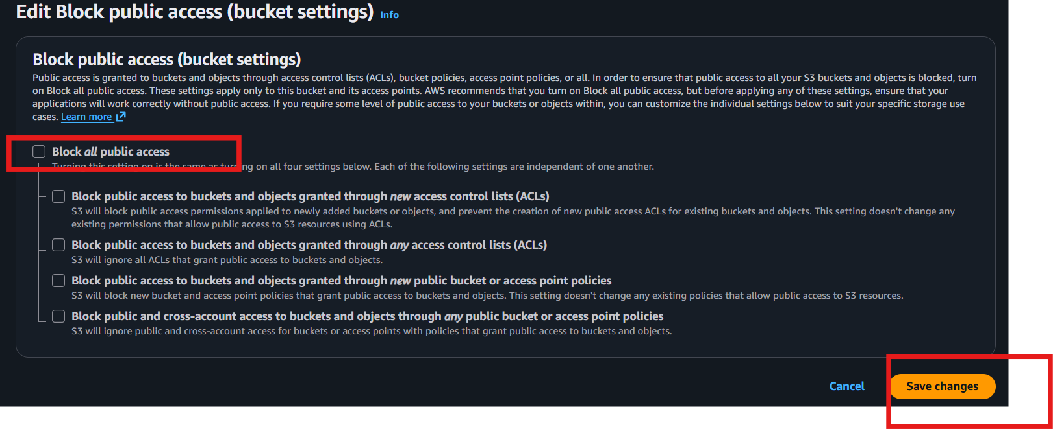
Now go to object - click on object - click Object URL
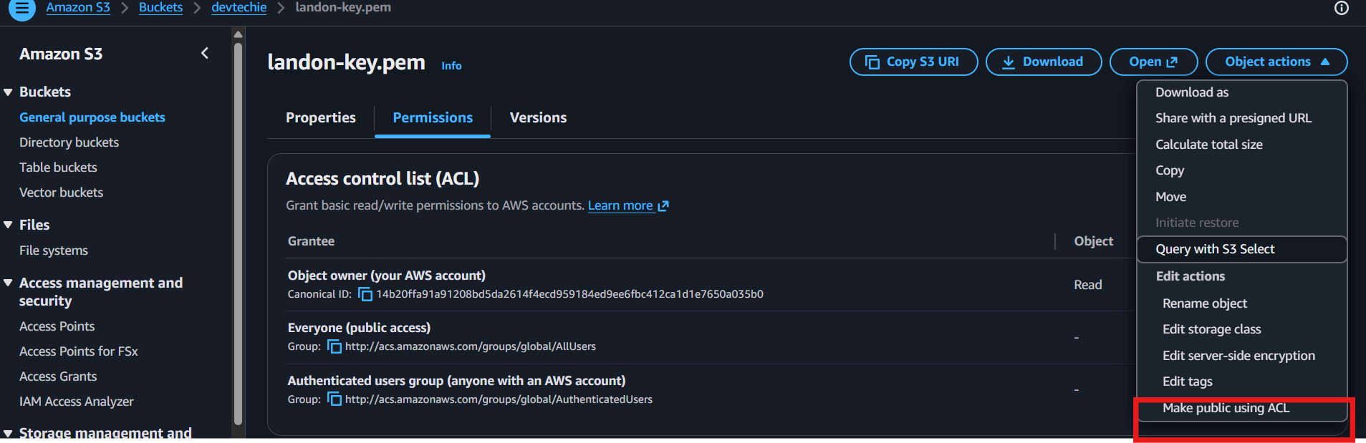
Now its showing so ACL ---? Click on ACL
And make public
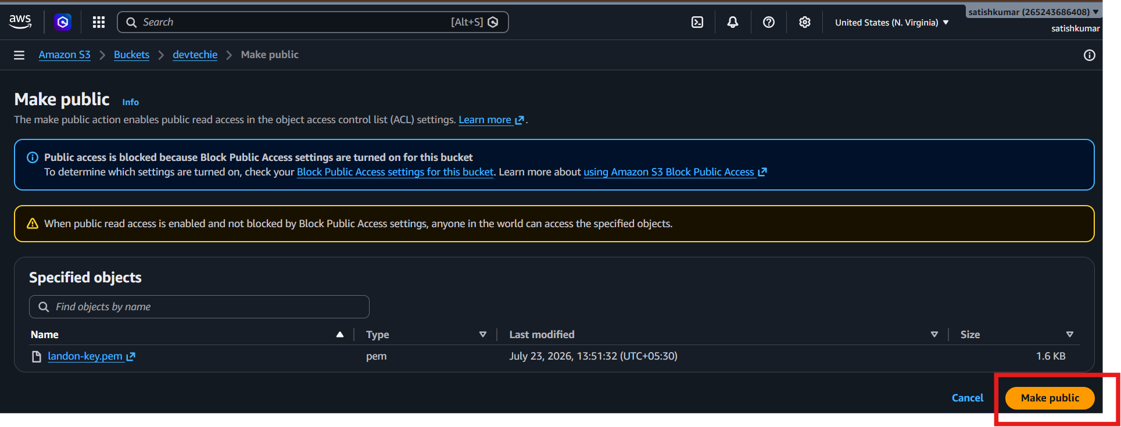

- Deploy a static website in the S3 bucket.
Step 1: Open the S3 Bucket
- Go to AWS Console → S3.
- Select your bucket.

Step 3: Enable Static Website Hosting
- Go to the Properties tab.
- Scroll to Static website hosting.
- Click Edit.
- Select Enable.
- Choose Host a static website.
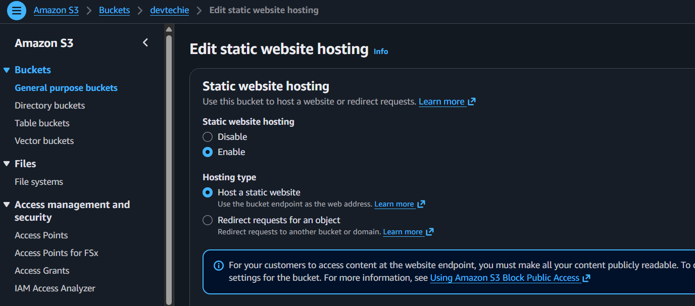
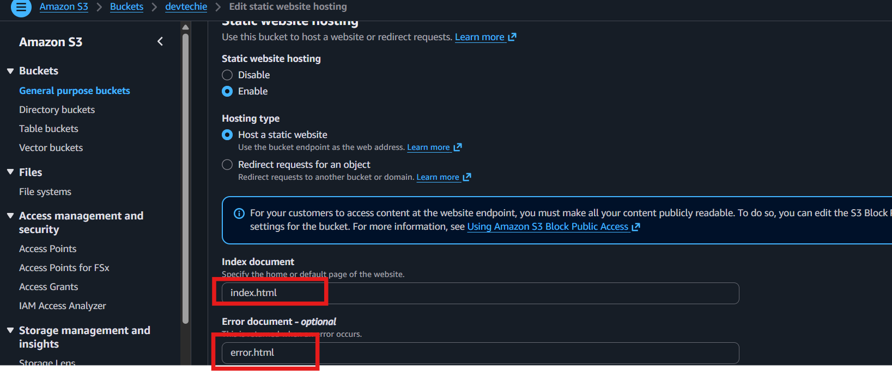
- Enter:
  - Index document: index.html
  - Error document: error.html (optional)
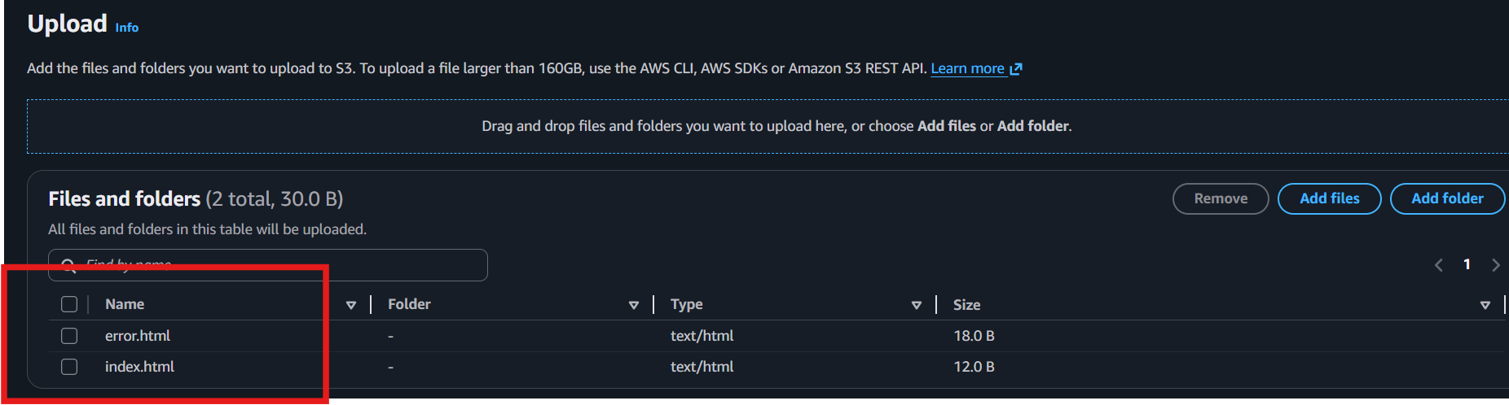
- Click Save changes.

Step 4: Allow Public Access
- Go to the Permissions tab.
- Under Block public access, click Edit.
- Uncheck Block all public access.
- Save the changes and confirm.
Step 5: Add a Bucket Policy
Go to Permissions → Bucket policy and paste the following (replace YOUR_BUCKET_NAME):
{
"Version": "2012-10-17",
"Statement": [
{
"Sid": "PublicRead",
"Effect": "Allow",
"Principal": "*",
"Action": "s3:GetObject",
"Resource": "arn:aws:s3:::YOUR_BUCKET_NAME/*"
}
]
}
Click Save changes.
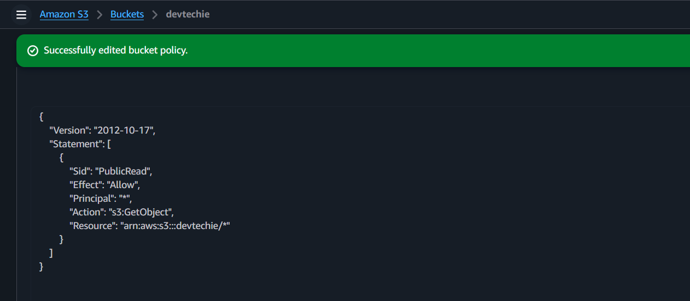
Step 6: Open the Website
- Go back to Properties.
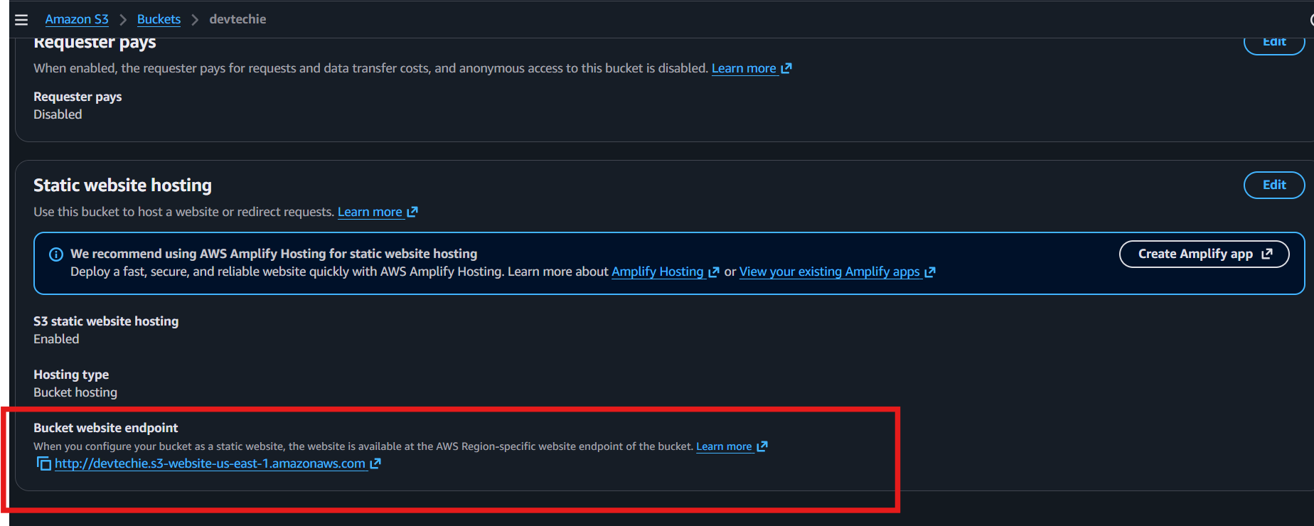
- Under Static website hosting, copy the Bucket website endpoint.
- Open the URL in your browser.
Outcome:
- ✅ Static website is hosted on S3.
- ✅ Website is accessible using the S3 website endpoint URL. .
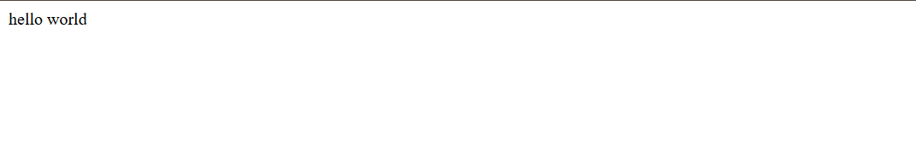

- Enable cross-region replication on S3 buckets.
Prerequisites
- Create 2 versioning-enabled S3 buckets in different AWS Regions.
  - Source: devtechie-source (us-east-1)
  - Destination: devtechie-destination (us-Ohio)

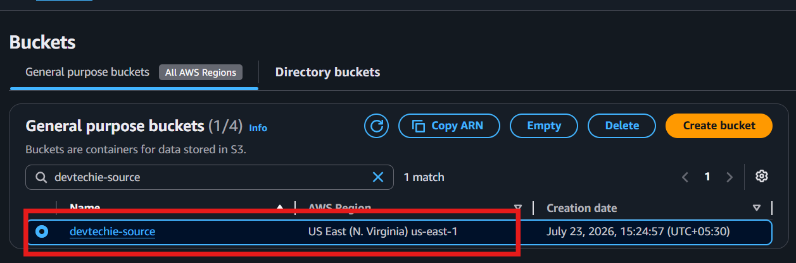
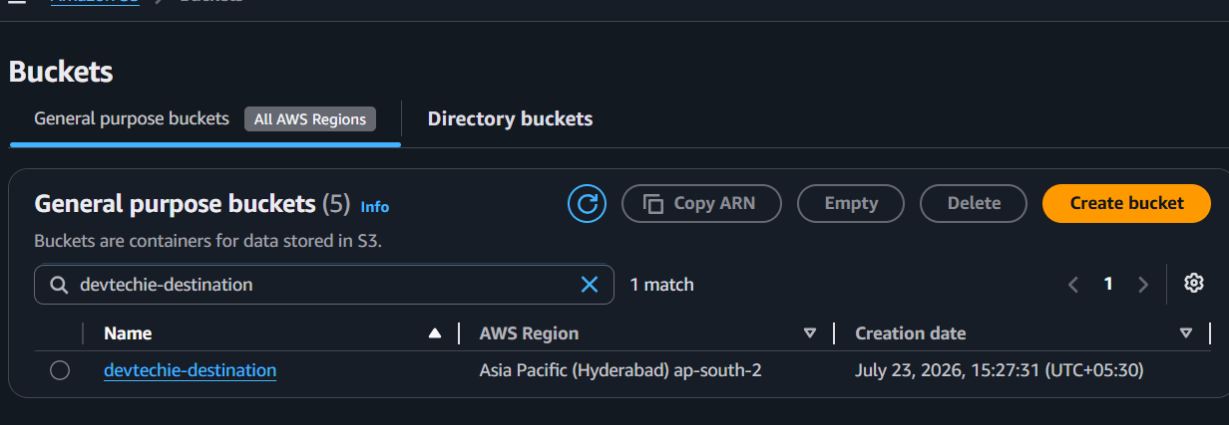
Steps
- Go to AWS Console → S3.
- Open the source bucket.
- Go to Properties → Bucket Versioning → Enable.
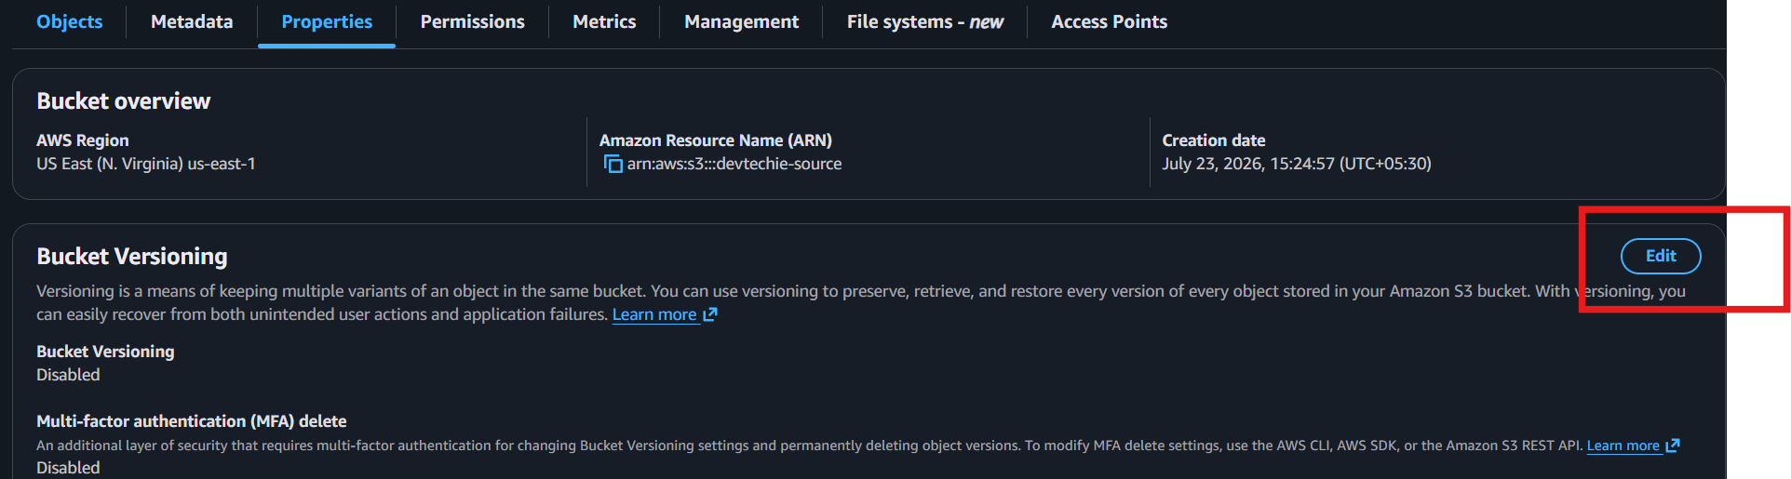
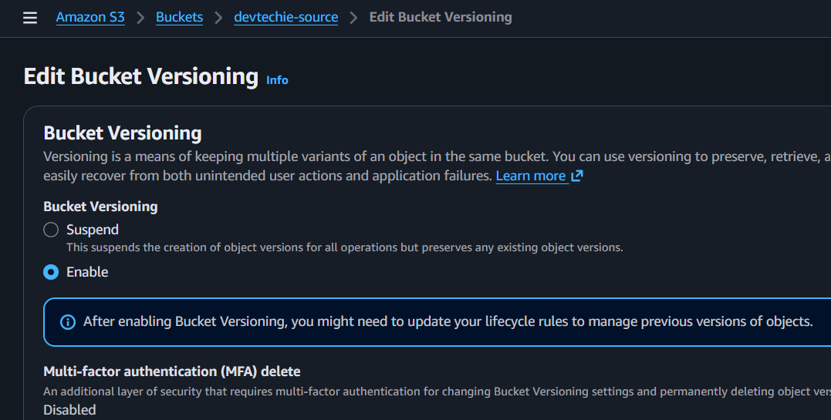
- Open the destination bucket → Properties → Bucket Versioning → Enable.
- Go back to the source bucket.
- Select Management → Replication rules → Create replication rule.
- Enter a Rule name (e.g., CRR-Rule).
- Select Apply to all objects.
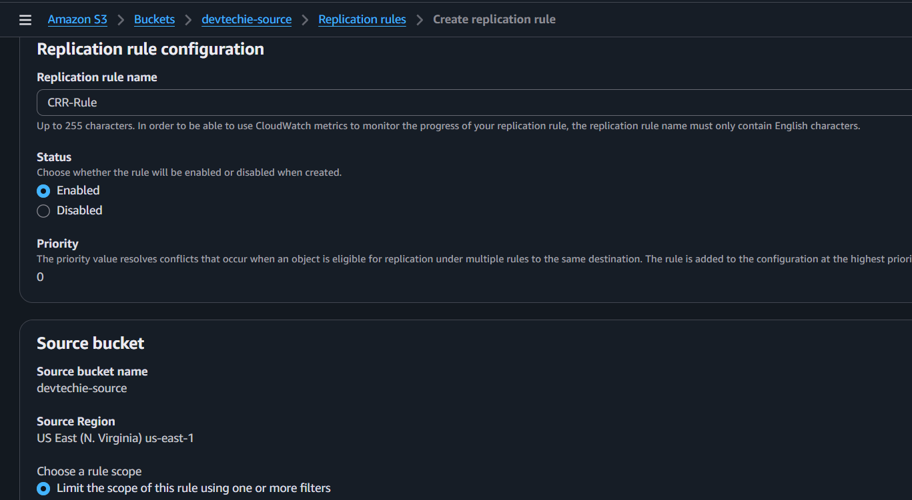
- Choose the destination bucket (in a different region).
- Select Create new IAM role (AWS creates it automatically).
- Click Save/Create rule.
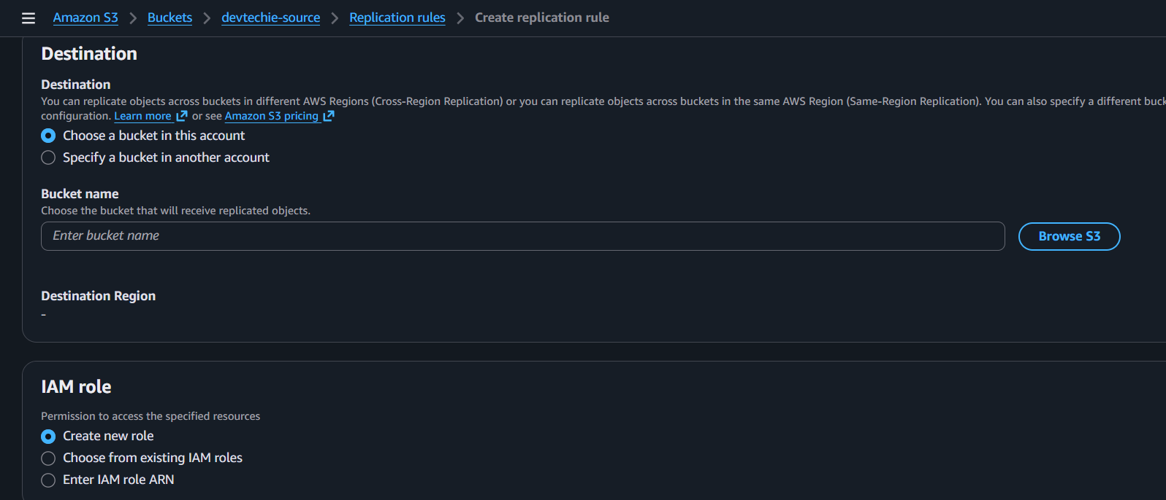

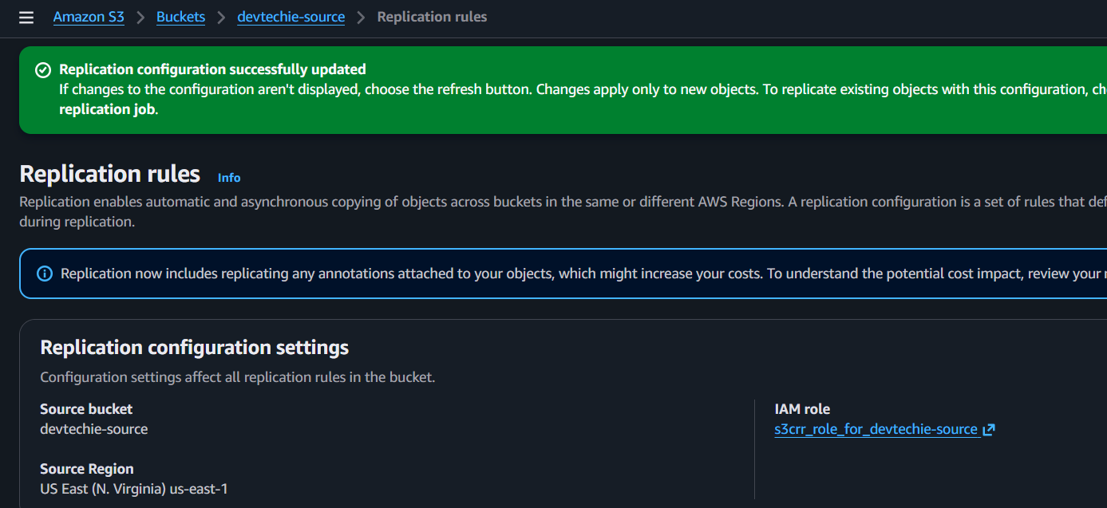
- Upload a new file to the source bucket.
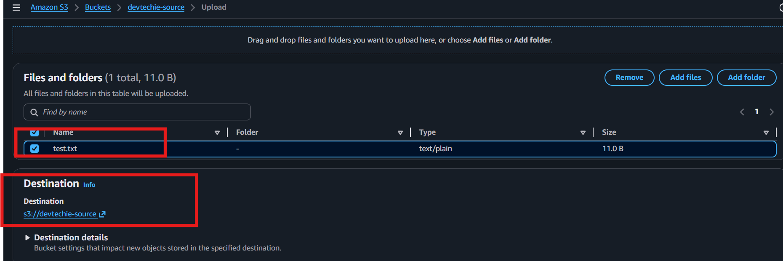
- Open the destination bucket and verify the file is replicated.
Outcome
- ✅ Cross-Region Replication is enabled.
- ✅ New objects uploaded to the source bucket are automatically copied to the destination bucket.
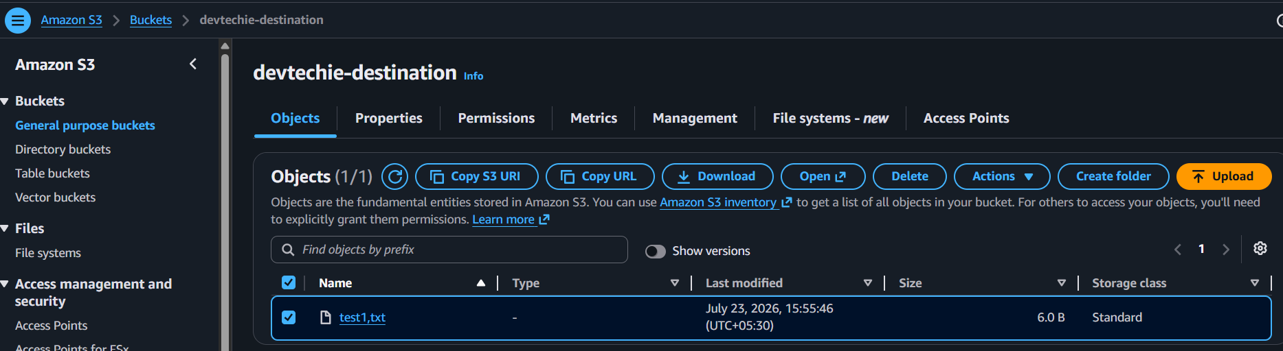

- Configure a bucket policy so only the Admin user can see the objects of the S3 bucket.
Step 1
Go to AWS Console → S3 → Open your bucket.
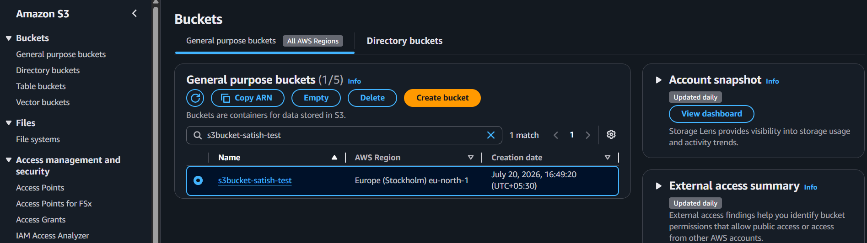

Step 2
Go to Permissions → Bucket Policy → Edit.
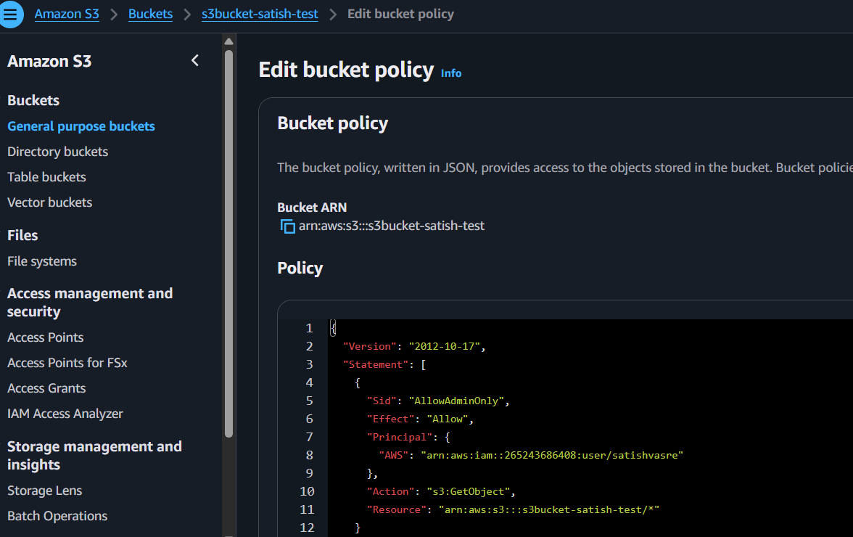

Click Save changes.
Step 6
Test:
- Log in as the Admin IAM user → You can view/download the objects.
- Log in as any other IAM user → Access is denied (assuming they do not have another IAM policy granting access).
Outcome: ✅ Only the specified Admin IAM user can access the objects in the S3 bucket.
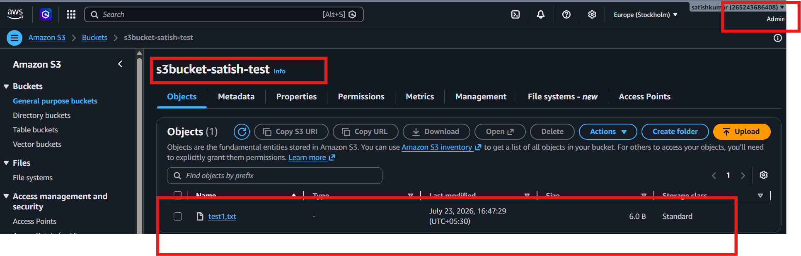
- Set up lifecycle policies to automatically transition or delete objects based on specific criteria..
Step 1
Go to AWS Console → S3 → Open your bucket.
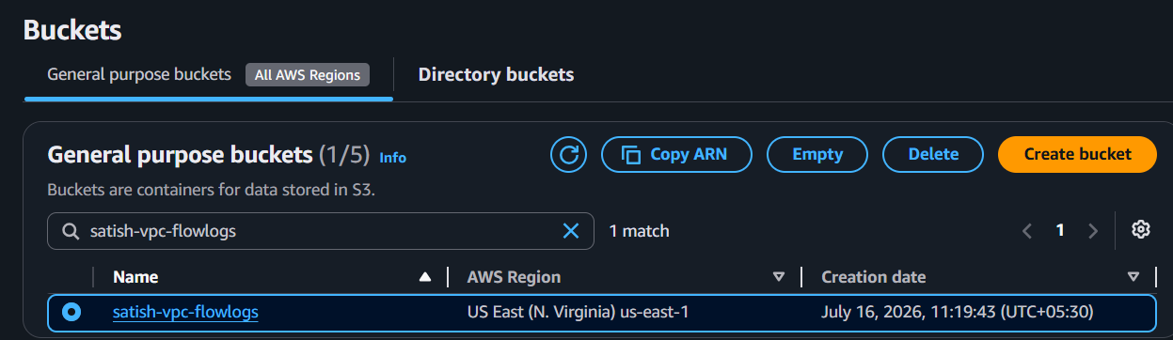
Step 2
Click the Management tab.
Step 3
Under Lifecycle rules, click Create lifecycle rule.

Step 4
Enter a Rule name (e.g., Lifecycle-Rule).
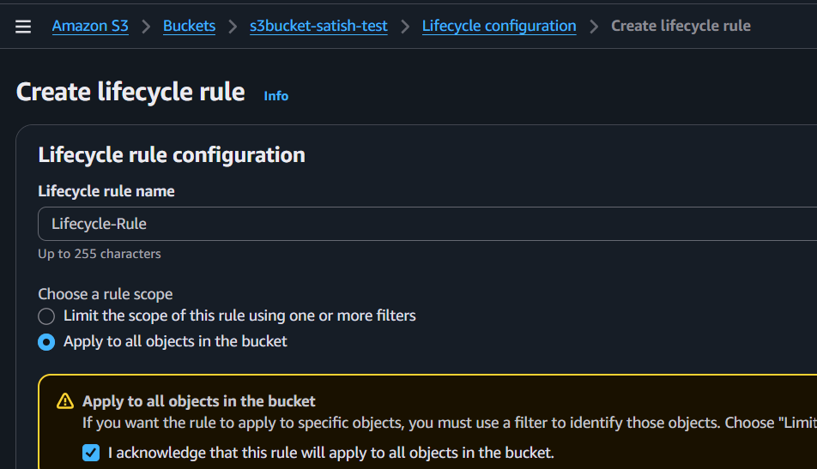
Step 5
Choose:
- ✅ Apply to all objects in the bucket.
Step 6
Under Lifecycle rule actions, select one of the following:
- ✅ Transition current versions of objects between storage classes
  - Example: Transition to S3 Standard-IA after 30 days.
OR
- ✅ Expire current versions of objects
  - Example: Delete objects after 30 days.
For a lab/assignment, you can choose either transition or expiration, depending on the requirement.
Step 7
Review the settings and click Create rule.
Outcome
- ✅ Lifecycle policy is created.
- ✅ Objects will automatically transition to another storage class or be deleted based on the configured number of days.
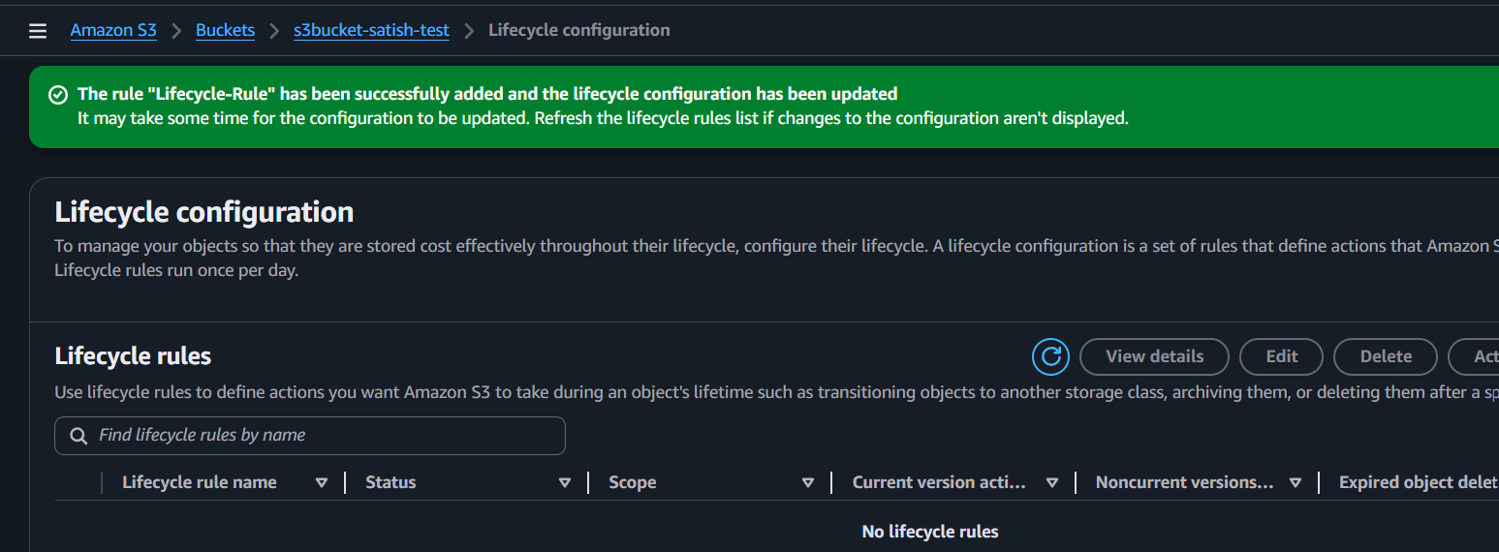

- Push some objects to S3 using the AWS CLI.
Steps
- Open Git Bash.
- Verify AWS CLI is installed:
aws –version
- Configure AWS CLI
aws configure
- Upload a file:
aws s3 cp test.txt s3://s3bucket-satish-test/
- Verify the upload:
aws s3 ls s3://s3bucket-satish-test/
If your file is in another folder
Navigate to the folder first:
aws s3 cp /c/Users/YourName/Downloads/test.txt s3://s3bucket-satish-test/
So yes, Git Bash, Command Prompt, PowerShell, and Windows Terminal all work with the AWS CLI.
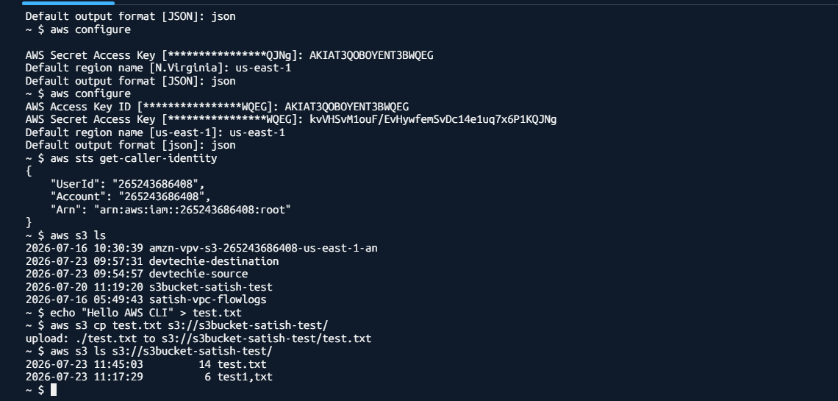

- Write a Bash script to create an S3 bucket.
Step 1
Open CloudShell, Git Bash, or Linux terminal.
Step 2
Create a script file:
nano create_s3_bucket.sh
Step 3
Add the following script:
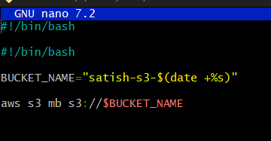
Step 4
Save and exit.
Step 5
Give execute permission:
chmod +x create_s3_bucket.sh
Step 6
Run the script:
./create_s3_bucket.sh
Step 7
Verify the bucket:
aws s3 ls
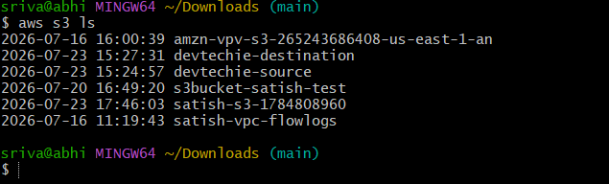
Outcome: ✅ A new S3 bucket is created successfully using the Bash script.
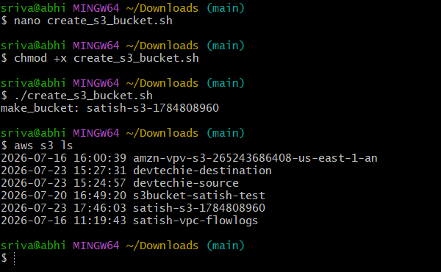

- Upload a 1 GB file to S3 using the CLI.
Step 1: Open Git Bash
Go to your Downloads folder:
cd ~/Downloads

Step 2: Create a 1 GB file
Run:
truncate -s 1G test1GB.bin

Step 3: Verify the file
Run:
ls -lh test1GB.bin
You should see:
-rw-r--r-- 1 ... 1.0G test1GB.bin
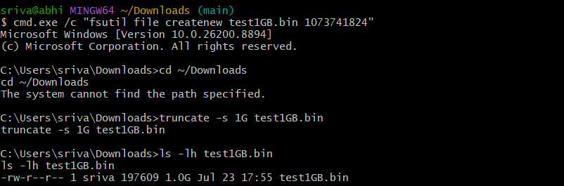

Step 4: Upload the file to S3
Run:
aws s3 cp test1GB.bin s3://s3bucket-satish-test/
upload: ./test1GB.bin to s3://s3bucket-satish-test/test1GB.bin
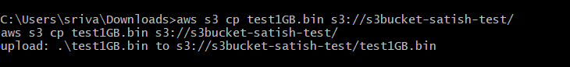

Step 5: Verify the upload
Run: aws s3 ls s3://s3bucket-satish-test/
